UNIQUE Constraint

🌟 Definition
# Source: AI Source: Provided by: [Data Path: Persons Table -> ID Column: 1, Name_En Column: Motasem Essam] -> From: [ChatGPT] on [6/10/2026]
A UNIQUE Constraint is a rule that ensures all values in a column (or a combination of columns) are unique.
It prevents duplicate values from being stored in the constrained column.

🎯 Purpose
# Source: AI Source: Provided by: [Data Path: Persons Table -> ID Column: 1, Name_En Column: Motasem Essam] -> From: [ChatGPT] on [6/10/2026]
The UNIQUE constraint is used to:
- Prevent duplicate data
- Enforce business rules
- Maintain data integrity
- Ensure uniqueness of important attributes

🧠 Simple Example
# Source: AI Source: Provided by: [Data Path: Persons Table -> ID Column: 1, Name_En Column: Motasem Essam] -> From: [ChatGPT] on [6/10/2026]
Users Table
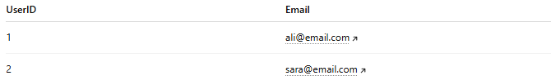
UserID | Email
1 | ali@email.com
2 | sara@email.com
If the Email column has a UNIQUE constraint:
✅ Valid
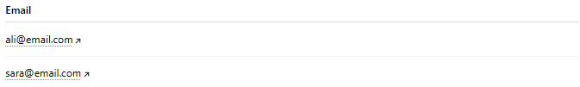
Email
ali@email.com
sara@email.com

❌ Invalid
Email
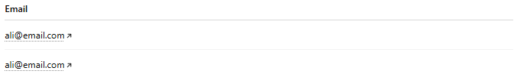
ali@email.com
ali@email.com
Duplicate email addresses are not allowed.

🔢 How UNIQUE Works
# Source: AI Source: Provided by: [Data Path: Persons Table -> ID Column: 1, Name_En Column: Motasem Essam] -> From: [ChatGPT] on [6/10/2026]
Without UNIQUE:
Email
-----
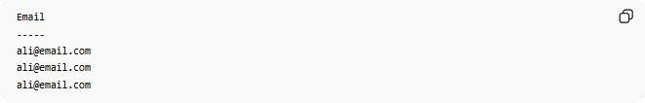
ali@email.com
ali@email.com
ali@email.com
Duplicates are allowed.

With UNIQUE:
Email
-----
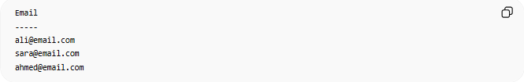
ali@email.com
sara@email.com
ahmed@email.com
Duplicates are rejected.

📚 Real-World Examples
# Source: AI Source: Provided by: [Data Path: Persons Table -> ID Column: 1, Name_En Column: Motasem Essam] -> From: [ChatGPT] on [6/10/2026]
1. Email Address
Each user must have a unique email.

2. Username
Each username must be unique.

3. National ID
Each citizen has a unique national ID.

4. Product Barcode
Each product barcode is unique.

🗄️ SQL Example
# Source: AI Source: Provided by: [Data Path: Persons Table -> ID Column: 1, Name_En Column: Motasem Essam] -> From: [ChatGPT] on [6/10/2026]
Create Table
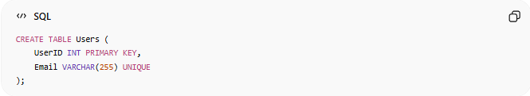
CREATE TABLE Users (
UserID INT PRIMARY KEY,
Email VARCHAR(255) UNIQUE
);

Valid Insert
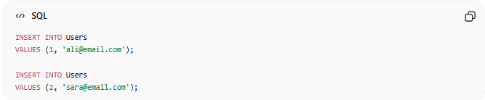
INSERT INTO Users
VALUES (1, 'ali@email.com');
INSERT INTO Users
VALUES (2, 'sara@email.com');
Result:
Success

Invalid Insert
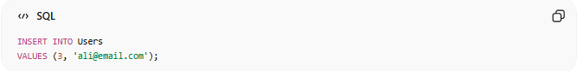
INSERT INTO Users
VALUES (3, 'ali@email.com');
Result:
Error
Because the email already exists.

📊 Database Example
# Source: AI Source: Provided by: [Data Path: Persons Table -> ID Column: 1, Name_En Column: Motasem Essam] -> From: [ChatGPT] on [6/10/2026]
Customers Table
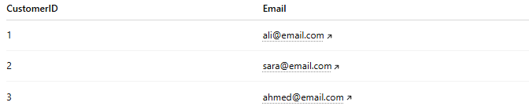
CustomerID | Email
1 | ali@email.com
2 | sara@email.com
3 | ahmed@email.com
UNIQUE column:
Email

Invalid Data
CustomerID | Email
4 | ali@email.com
Duplicate value detected.

🔢 Characteristics of UNIQUE
# Source: AI Source: Provided by: [Data Path: Persons Table -> ID Column: 1, Name_En Column: Motasem Essam] -> From: [ChatGPT] on [6/10/2026]
A UNIQUE constraint:
- Prevents duplicates
- Maintains data consistency
- Can be applied to one or more columns
- Is commonly used on business identifiers

🔗 Composite UNIQUE Constraint
# Source: AI Source: Provided by: [Data Path: Persons Table -> ID Column: 1, Name_En Column: Motasem Essam] -> From: [ChatGPT] on [6/10/2026]
Sometimes uniqueness is based on multiple columns together.

Example
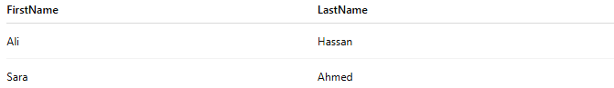
FirstName | LastName
Ali | Hassan
Sara | Ahmed
Suppose the combination:
(FirstName, LastName)
must be unique.

SQL Example
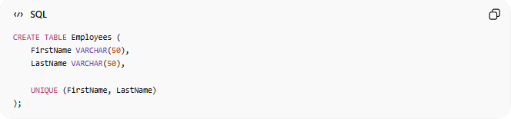
CREATE TABLE Employees (
FirstName VARCHAR(50),
LastName VARCHAR(50),
UNIQUE (FirstName, LastName)
);
The combination must be unique.

⚠️ UNIQUE vs Primary Key
# Source: AI Source: Provided by: [Data Path: Persons Table -> ID Column: 1, Name_En Column: Motasem Essam] -> From: [ChatGPT] on [6/10/2026]
Similarities
Both:
- Enforce uniqueness
- Prevent duplicates

Differences
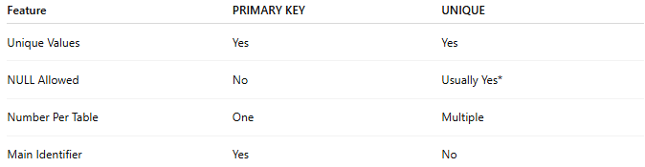
Feature | PRIMARY KEY | UNIQUE
Unique Values | Yes | Yes
NULL Allowed | No | Usually Yes*
Number Per Table | One | Multiple
Main Identifier | Yes | No
* Behavior varies by database system.

Example
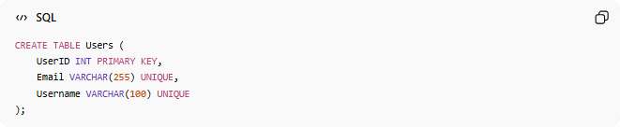
CREATE TABLE Users (
UserID INT PRIMARY KEY,
Email VARCHAR(255) UNIQUE,
Username VARCHAR(100) UNIQUE
);
Table contains:
- One Primary Key
- Two UNIQUE constraints

🌍 Student Example
# Source: AI Source: Provided by: [Data Path: Persons Table -> ID Column: 1, Name_En Column: Motasem Essam] -> From: [ChatGPT] on [6/10/2026]
Students Table
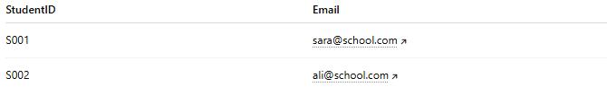
StudentID | Email
S001 | sara@school.com
S002 | ali@school.com
Rule:
No two students can share the same email.
UNIQUE enforces this rule.

⚠️ UNIQUE vs NOT NULL
# Source: AI Source: Provided by: [Data Path: Persons Table -> ID Column: 1, Name_En Column: Motasem Essam] -> From: [ChatGPT] on [6/10/2026]
UNIQUE
No duplicates allowed.

NOT NULL
No empty values allowed.

Comparison
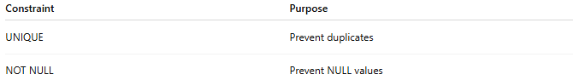
Constraint | Purpose
UNIQUE | Prevent duplicates
NOT NULL | Prevent NULL values

Example
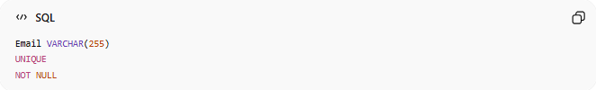
Email VARCHAR(255)
UNIQUE
NOT NULL
This means:
Must have a value
Must be unique

📚 Common UNIQUE Fields
# Source: AI Source: Provided by: [Data Path: Persons Table -> ID Column: 1, Name_En Column: Motasem Essam] -> From: [ChatGPT] on [6/10/2026]
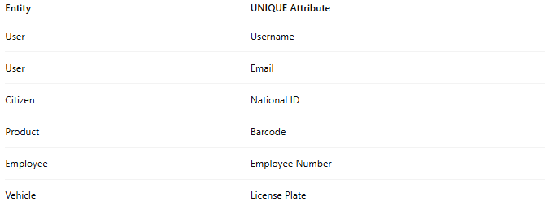
Entity | UNIQUE Attribute
User | Username
User | Email
Citizen | National ID
Product | Barcode
Employee | Employee Number
Vehicle | License Plate

🧠 Simple Analogy
# Source: AI Source: Provided by: [Data Path: Persons Table -> ID Column: 1, Name_En Column: Motasem Essam] -> From: [ChatGPT] on [6/10/2026]
Think of usernames on a website:

ali123
sara456
ahmed789
Two users cannot register:
ali123
at the same time.
Each username must be unique.
This is exactly what a UNIQUE Constraint enforces.

🧭 Summary
# Source: AI Source: Provided by: [Data Path: Persons Table -> ID Column: 1, Name_En Column: Motasem Essam] -> From: [ChatGPT] on [6/10/2026]
A UNIQUE Constraint is a rule that prevents duplicate values from being stored in a column or group of columns. It helps maintain data integrity by ensuring that values such as email addresses, usernames, national IDs, and barcodes remain unique across all records in a table.

